Project Design Phase-II
Data Flow Diagram & User Stories

Date | 28 September 2026
Team ID | SWTID-2026-3101
Project Name | BlogNestAPI
Maximum Marks | 4 Marks

1. Data Flow Diagrams
Data Flow Diagram (DFD): A Data Flow Diagram is a visual representation of how information moves through AI BlogNestAPI. It shows how data enters and leaves the system, how the application processes information, and where information is stored.
2. DFD Level 0 — Context Diagram
External entities and major data flows:
• User → AI BlogNestAPI: registration, login credentials, blog data, comments, and AI content prompts.
• AI BlogNestAPI → User: authentication response, blog data, comments, validation messages, and AI-generated content.
• AI BlogNestAPI ↔ Database: user records, authentication-related data, blog posts, and comments.
• AI BlogNestAPI ↔ AI Service: content-generation request and generated content response.
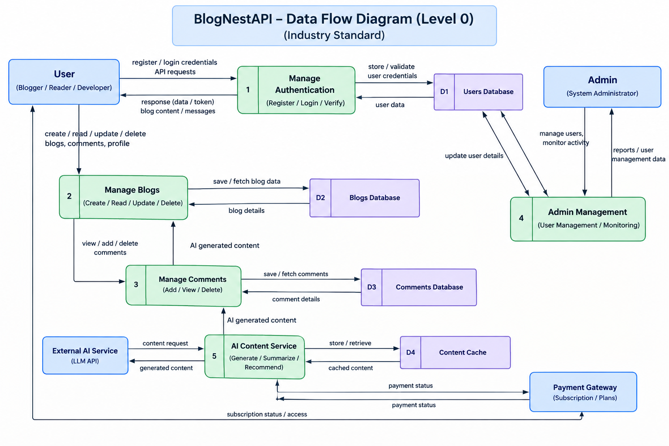

User Stories
Use the below template to list all the user stories for the product.
User Type | Functional Requirement (Epic) | User Story Number | User Story / Task | Acceptance Criteria | Priority | Release
Customer (API User) | Registration | USN-1 | As a user, I can register for AI BlogNestAPI by entering my email, password, and confirming my password. | Valid details create an account and return a successful response. | High | Sprint-1
Customer (API User) | Registration | USN-2 | As a user, I receive confirmation after successfully registering for the application. | Registration is completed and confirmation/status is returned. | High | Sprint-1
Customer (API User) | Authentication | USN-3 | As a user, I can log into AI BlogNestAPI using my email and password. | Valid credentials authenticate the user successfully. | High | Sprint-1
Customer (API User) | Authentication | USN-4 | As an authenticated user, I can access protected API resources. | Valid authentication allows access; invalid authentication is rejected. | High | Sprint-1
Customer (API User) | Blog Management | USN-5 | As a user, I can create a blog post with a title and content. | A valid blog post is stored and returned successfully. | High | Sprint-1
Customer (API User) | Blog Management | USN-6 | As a user, I can view available blog posts. | The API returns the requested blog post data. | High | Sprint-1
Customer (API User) | Blog Management | USN-7 | As an authorized user, I can update my blog post. | The selected post is updated successfully. | High | Sprint-2
Customer (API User) | Blog Management | USN-8 | As an authorized user, I can delete my blog post. | The selected post is deleted successfully. | High | Sprint-2
Customer (API User) | Comment Management | USN-9 | As a user, I can add a comment to a blog post. | A valid comment is stored against the selected post. | Medium | Sprint-2
Customer (API User) | Comment Management | USN-10 | As a user, I can view comments for a blog post. | Comments for the selected post are returned. | Medium | Sprint-2
Customer (API User) | AI Content Assistance | USN-11 | As a user, I can submit a prompt to generate AI-assisted blog content. | A valid prompt is accepted and processed by the AI service. | High | Sprint-3
Customer (API User) | AI Content Assistance | USN-12 | As a user, I can receive AI-generated content from the API. | Generated content is returned in the expected API response format. | High | Sprint-3
Customer (API User) | Validation & Error Handling | USN-13 | As a user, I receive clear errors when invalid or incomplete data is submitted. | The API returns an appropriate validation/error response. | Medium | Sprint-3
Administrator / Project Team | Testing & Integration | USN-14 | As a project team, we can test all major API endpoints. | Core endpoints pass planned positive and negative test scenarios. | High | Sprint-4
Administrator / Project Team | Documentation | USN-15 | As a project team, we can document the API and project workflow. | API behavior and project workflow are documented for users and reviewers. | Medium | Sprint-4

